ONLINE AUCTION SYSTEM WITH REAL-TIME BIDDING

A CAPSTONE PROJECT REPORT

Submitted in the partial fulfilment for the Course of

CSA1012 SOFTWARE ENGINEERING

to the award of the degree of

BACHELOR OF ENGINEERING

IN

INFORMATION TECHNOLOGY

Submitted by

S.AMIRTHAVALLI (192521365)

Under the Supervision of

Dr. K.Anita Davamani
Project GitHub Repository: https://github.com/Amirtha6380/online-auction.git



SIMATS ENGINEERING

Saveetha Institute of Medical and Technical Sciences

Chennai-602105

July 2026

INDEX

SNO | TITLE | PG.NO
1. | PROBLEM EXPLANATION | 6
2. | IDENTIFY KEY STAKEHOLDERS | 8
3. | ANALYZE THE CURRENT APPROACH | 10
4. | PROPOSED SOFTWARE SOLUTION USING SE PRINCIPLES | 11
5. | JUSTIFICATION OF SDLC/FRAMEWORK | 16
6. | EXPECTED OUTCOMES AND LIMITATIONS | 17
7. | CONCLUSION | 19
CODE REVIEW AND REPOSITORY EVALUATION
ONLINE AUCTION SYSTEM WITH REAL-TIME BIDDING

1. PROBLEM OVERVIEW
1.1 Introduction
An online auction system is a software application that allows users to participate in auctions through the internet. Traditional auctions require bidders to be physically present at a particular location. This creates limitations related to time, location, accessibility, and participation.
The proposed project, Online Auction System with Real-Time Bidding, provides a digital platform where users can view auction items and participate in bidding. The system allows users to log in, view available auction items, enter bids, and receive appropriate responses based on the auction status.
The system is designed to provide a simple, user-friendly, and reliable environment for conducting online auctions. It also validates bidding activities and prevents users from placing bids after the auction has ended.

1.2 Problem Statement
Traditional auction systems require participants to attend auctions physically or depend on manual communication methods. Such systems can be time-consuming and difficult to manage when there are many participants.
The main problem addressed by this project is the development of an online platform that allows users to participate in auctions remotely. The system should provide controlled access to users, display auction information, accept valid bids, and handle auction completion appropriately.

1.3 Proposed Solution
The proposed Online Auction System provides a web-based interface for conducting auction activities.
The system provides:
- User login functionality.
- Auction item display.
- Bidding functionality.
- Bid validation.
- Auction status management.
- Prevention of bidding after the auction ends.
- User-friendly web interface.
- Containerized application deployment using Docker, where applicable.
The system separates different responsibilities of the application so that the source code can be maintained and modified more easily.

1.4 Project Objectives
The major objectives of the project are:
- To develop an online platform for conducting auctions.
- To allow users to access the auction system through a web interface.
- To provide secure user login functionality.
- To display available auction items and their details.
- To allow users to submit bids.
- To validate submitted bids.
- To prevent bidding after an auction has ended.
- To maintain an organized and maintainable source-code repository.
- To use Git for version control and project management.
- To use Docker for consistent application execution and deployment, where applicable.

1.5 Key Functionalities
User Login
Users can enter their credentials through the login page to access the auction system.
Auction Display
The system displays auction-related information such as the item, current bid, and auction status.
Bid Submission
A user can submit a bid for an available auction item.
Bid Validation
The system validates whether the submitted bid is acceptable according to the implemented auction rules.
Auction Status
The system identifies whether an auction is currently active or has ended.
Ended Auction Handling
When the auction period is completed, the system prevents further bidding and displays an appropriate message to the user.
1.6 Technologies Used
The project uses web-development and software-development technologies to implement the auction system.
- • Frontend: HTML, CSS, JavaScript
- • Backend: Python Flask
- • Database: SQLite
- • Programming Language: Python
- • Version Control: Git and GitHub
- • Containerization: Docker
- • Web Browser: Google Chrome

2. REPOSITORY ORGANIZATION
2.1 Repository Overview
The project source code is maintained in a Git repository. The repository contains the application source code, configuration files, documentation, and other resources required to run the project.
The repository provides a centralized location for managing the project and tracking changes made during development.
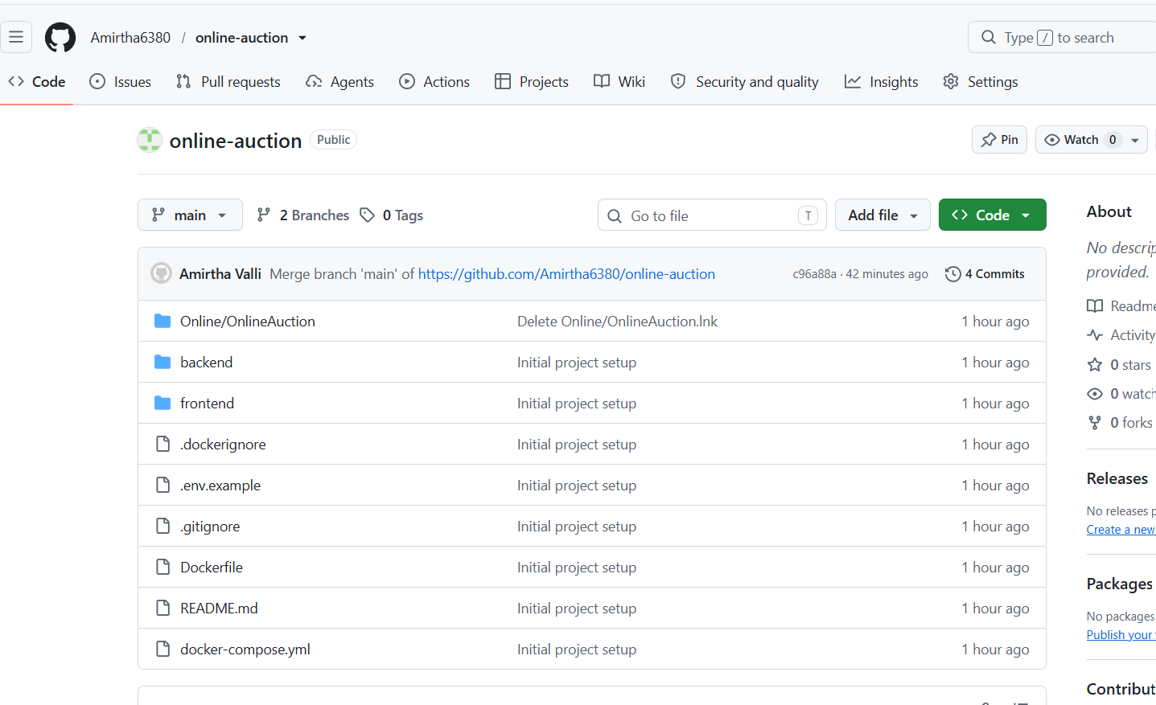
Figure 1: GitHub repository of the Online Auction System

2.2 Repository Structure
The repository is organized into different files and folders according to their purpose.
A typical structure of the project is: 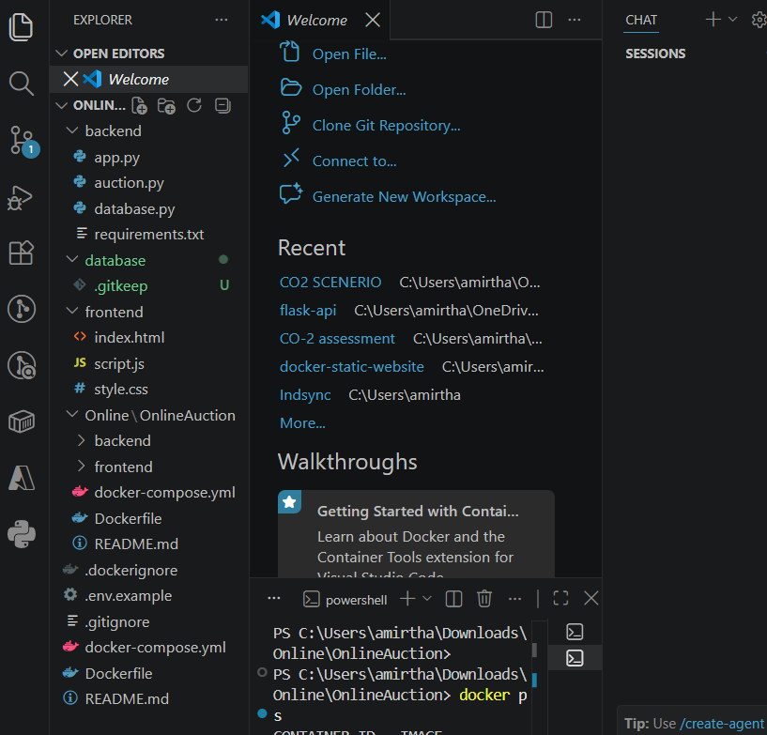
Figure 2: Project repository structure
2.3 Folder Organization
The project follows a logical organization by separating source files and configuration files according to their responsibilities.
For example:
- Frontend: Contains user interface-related files.
- Backend: Contains application logic and server-side functionality.
- Models: Represents data-related structures.
- Routes: Handles application routes or requests.
- Components: Contains reusable interface components.
- Database: Contains database-related configuration or scripts.
- README.md: Provides project documentation.
- Dockerfile: Defines instructions for building the application container.
- .gitignore: Prevents unnecessary files from being committed.
The exact organization depends on the implementation of the project.

2.4 File Naming Conventions
Meaningful file names improve the readability and maintainability of a software project.
Files should use names that clearly describe their purpose. For example:
- login
- auction
- bid
- user
- database
- server
Consistent naming makes it easier for developers to locate and understand project files.

2.5 Maintainability of Repository Structure
The repository structure supports maintainability because related files can be grouped together. Developers can identify the location of user-interface code, business logic, configuration, and documentation without searching the entire repository.
A well-organized structure also reduces development time when new features need to be added.
For example, a future feature such as an auction history module can be added without significantly changing unrelated parts of the application.

2.6 Collaboration Support
GitHub provides a centralized repository that can be accessed by multiple developers. Developers can work on different features, commit their changes, and merge changes into the main project.
Version control also makes it possible to identify previous versions of files and recover from unwanted changes.

3. CODE QUALITY REVIEW

3.1 Introduction
Code quality is an important factor in software development because readable and maintainable code reduces errors and makes future modifications easier.
The source code of the Online Auction System was reviewed based on:
- Readability
- Modularity
- Naming conventions
- Coding standards
- Comments and documentation
- Error handling
- Maintainability
- Reusability

3.2 Code Readability
The code should be written in a clear and understandable manner. Meaningful variable and function names make the purpose of each section easier to understand.

3.3 Modularity
The project can be improved and maintained more easily when different responsibilities are separated into modules.
The major logical modules of the system include:
- Login module
- User management
- Auction module
- Bidding module
- Auction status management
- Database or data management
- User interface
Modularity prevents the entire application from becoming dependent on a single large source file.

3.4 Coding Standards
The source code should follow consistent coding standards throughout the project.
Important practices include:
- Consistent indentation.
- Meaningful variable names.
- Meaningful function names.
- Avoiding unnecessary duplicate code.
- Proper use of comments.
- Separating business logic from presentation logic.
- Keeping functions focused on a single responsibility.
These practices make the application easier to understand and modify.

3.5 Code Documentation
Comments and documentation help developers understand complex sections of code.
Simple comments can be used to explain important logic, particularly:
- Bid validation.
- Auction status checking.
- User authentication.
- Database operations.
- Error handling.
However, comments should explain why a particular operation is performed rather than unnecessarily describing every line.

3.6 Code Review Example
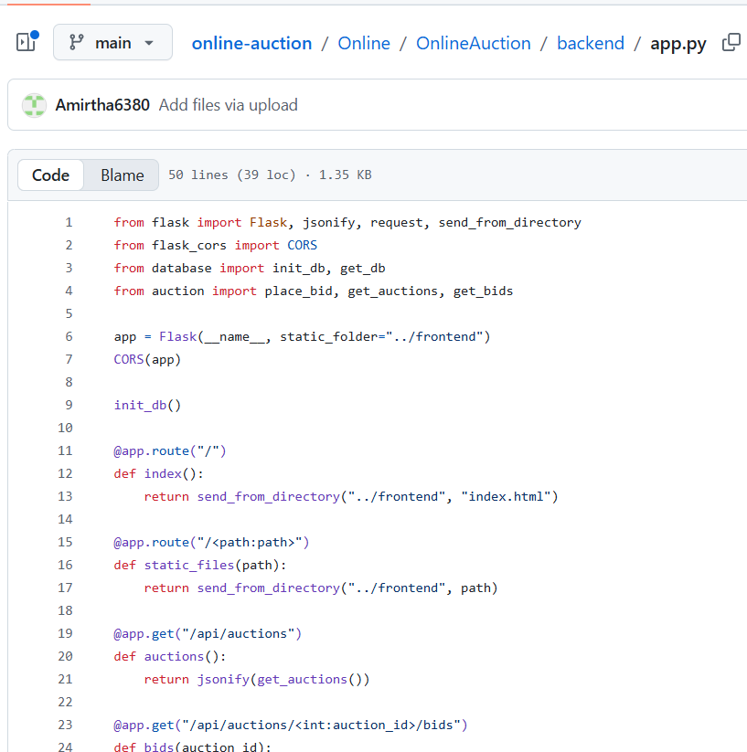

Figure 3: Source code showing login or authentication functionality
The selected code demonstrates the implementation of user access to the system. The code accepts user credentials and validates them before allowing access to the auction functionality.

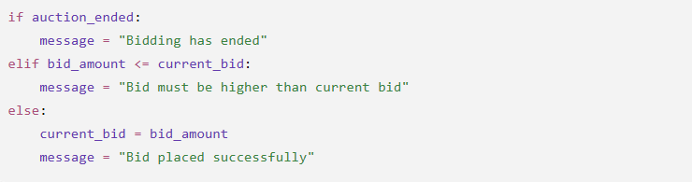

Figure 4: Source code showing bidding functionality
The bidding code demonstrates how a bid is processed and validated. The system checks the auction state before allowing the user to submit a bid.

3.7 Strengths Identified
The following strengths were identified during the review:
- The project has clearly identifiable login and auction functionalities.
- The application provides a simple user interface.
- Bidding functionality is separated logically from other operations.
- Auction status is considered during bidding.
- The project uses Git for source-code management.
- Docker can provide a consistent environment for running the application.
- The project can be extended with additional auction features.

3.8 Areas for Improvement
The following improvements can increase the quality of the source code:
- Use consistent naming conventions throughout the project.
- Reduce duplicate code.
- Separate business logic into reusable functions or modules.
- Add meaningful comments to complex sections.
- Improve error handling.
- Validate user input more strictly.
- Add automated tests.
- Improve documentation of functions and modules.
- Store configuration values securely.
10.Avoid hard-coded values where configuration files can be used.

4. VERSION CONTROL EVALUATION
4.1 Introduction
Git is a distributed version-control system used to track changes in source code. GitHub provides online repository hosting and supports collaboration between developers.
The Online Auction System repository uses Git/GitHub to maintain project versions and record development changes.
4.2 Commit History
The commit history provides information about the development progress of the project.
Each commit represents a set of changes made to the repository.
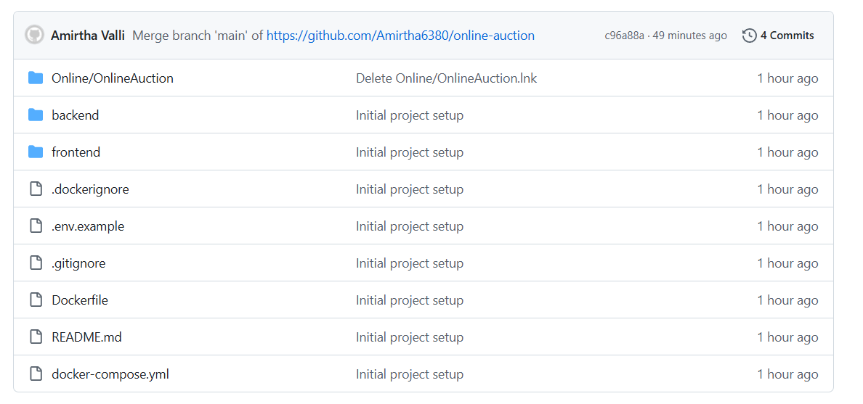
Figure 5: Git commit history
The commit history can be evaluated based on:
- Number of commits.
- Frequency of commits.
- Commit message clarity.
- Logical grouping of changes.
- Progression of development.

4.3 Commit Message Evaluation
Good commit messages should clearly explain what was changed.
Examples of good commit messages include:
Add login functionality
Implement auction item display
Add bid validation
Fix auction end condition
Update Docker configuration
Improve README documentation
Short and descriptive messages make the development history easier to understand.
Poor messages such as:
update
changes
final
new
test
provide limited information about the actual modification.

4.4 Branching Strategy
Git branches allow developers to work on separate features without directly modifying the stable version of the project.
A suitable branching strategy for future development would be:
main
│
├── feature/login
├── feature/auction
├── feature/bidding
└── feature/testing
The main branch can contain the stable version, while feature branches can be used for individual development tasks.
If the current project uses only the main branch,

a feature-based branching strategy can be adopted in future development.

4.5 Repository Maintenance
Repository maintenance involves keeping the project clean, updated, and properly documented.
Recommended practices include:
- Maintaining a useful README.
- Using .gitignore.
- Removing unnecessary files.
- Avoiding sensitive information in the repository.
- Using meaningful commit messages.
- Creating branches for major features.
- Regularly updating dependencies.
- Tagging stable versions when appropriate.

4.6 Importance of Version Control
Version control supports collaborative development by allowing developers to:
- Track changes.
- Compare versions.
- Restore previous versions.
- Work on separate branches.
- Merge changes.
- Identify contributors.
- Maintain a history of development.
Therefore, Git/GitHub significantly improves the maintainability and collaboration of the project.

5. CODE TESTING AND VALIDATION
5.1 Introduction
Testing is performed to verify that the application behaves according to the specified requirements.
The Online Auction System was tested using different functional test cases covering login, auction access, bidding, validation, and auction completion.
5.2 Testing Objectives
The main objectives of testing are:
- To verify that valid users can log in.
- To verify that invalid login details are handled correctly.
- To verify that auction information is displayed.
- To verify that valid bids are accepted.
- To verify that invalid bids are rejected.
- To verify that users cannot bid after the auction ends.
- To verify that the application runs successfully.

5.3 Test Cases
Test Case ID | Test Scenario | Input | Expected Result | Status
TC01 | Valid Login | Correct username and password | User is successfully logged in | Pass
TC02 | Invalid Login | Incorrect credentials | Login should be rejected | Pass
TC03 | Auction Page | Open auction page | Auction details should be displayed | Pass
TC04 | Valid Bid | Valid bid amount | Bid should be accepted | Pass
TC05 | Invalid Bid | Invalid/low bid amount | Bid should be rejected | Pass
TC06 | Ended Auction | Attempt to bid after auction ends | System should prevent bidding | Pass
TC07 | Page Navigation | Navigate between pages | Correct page should load | Pass
TC08 | Application Startup | Start application | Application should run successfully | Pass

5.4 Login Testing
The login page was tested by entering valid and invalid credentials.
For valid credentials, the system should allow the user to proceed to the auction page.
For invalid credentials, the system should prevent unauthorized access and display an appropriate error message.
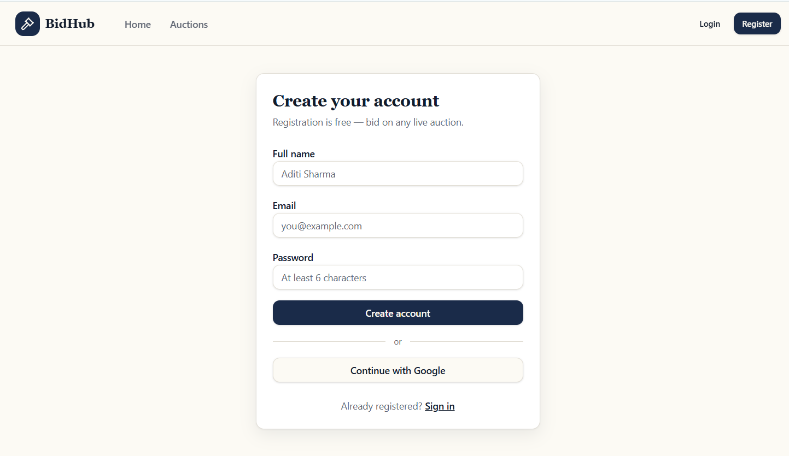

Figure 6: Login page of the Online Auction System

5.5 Auction Page Testing
After successful login, the user can access the auction page. The auction page displays relevant auction information.
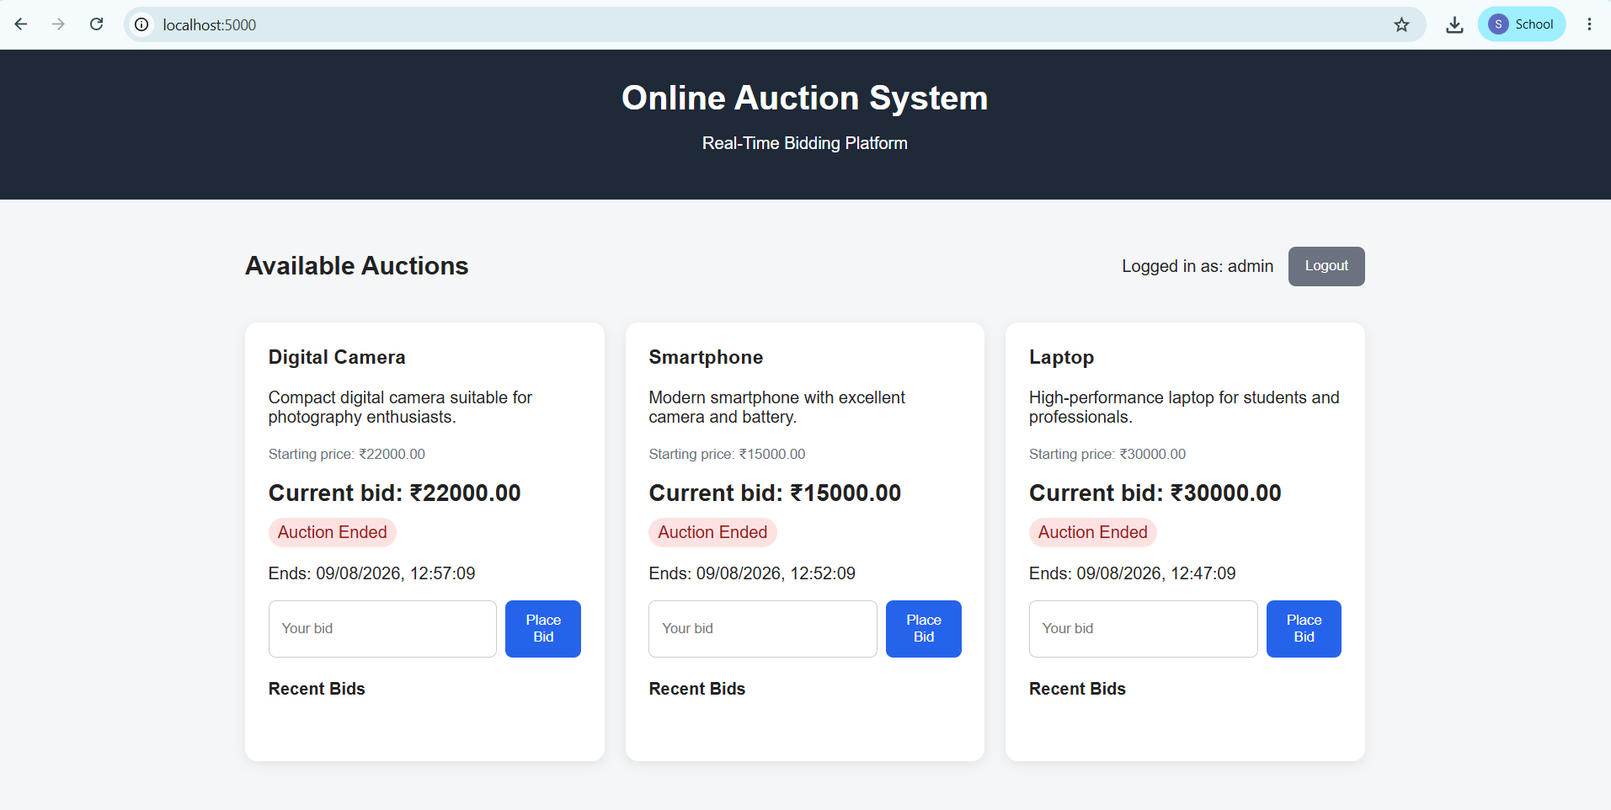

Figure 7: Auction and bidding page
The page was tested for correct loading of auction details and availability of the bidding functionality.

5.6 Bid Validation Testing
The bidding functionality was tested by entering bid values.
The system should validate the submitted value according to the implemented auction rules.
Invalid bids should not be accepted.

5.7 Auction End Testing
An important validation condition is the auction-ending condition.
When the auction has ended, users should not be allowed to place new bids.
During testing, the application displayed an appropriate message indicating that bidding had ended.
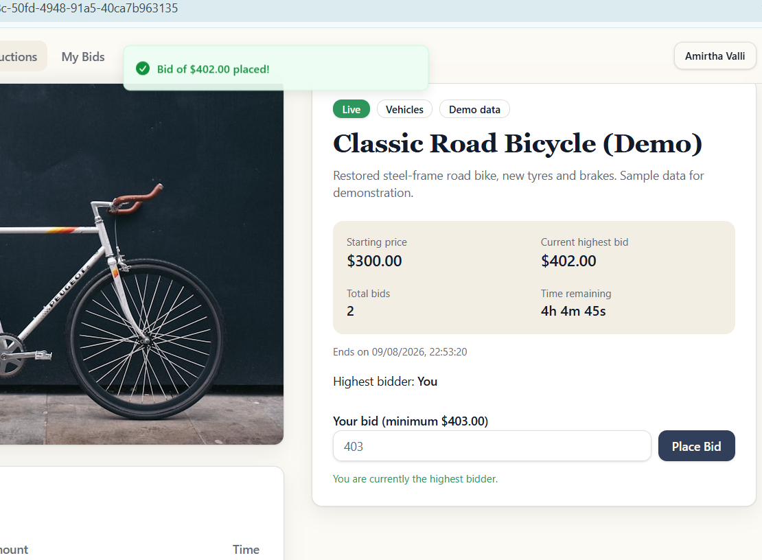
Figure 8: Auction-ended validation message

5.8 Application Execution Testing
The complete application was executed locally to verify that all required components started correctly.
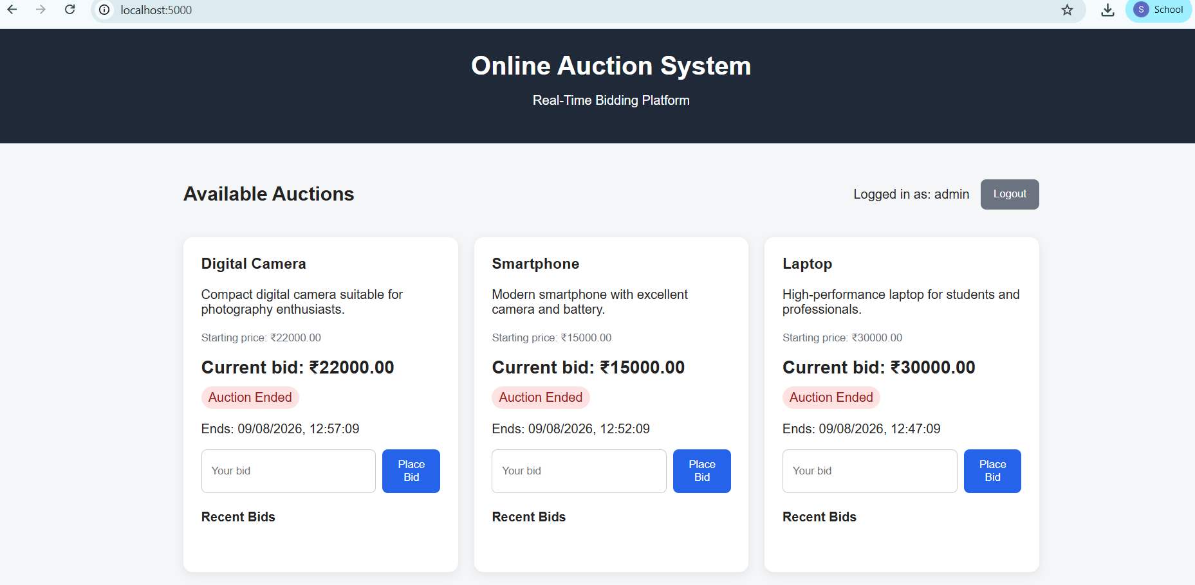
Figure 9: Online Auction System running on localhost

If Docker was used, the Docker containers were started and the application was accessed through the configured localhost port.

6. REPOSITORY DOCUMENTATION
6.1 README Evaluation
The README file is an important part of the repository because it provides information required by developers or users to understand and run the project.
A good README should contain:
- Project title.
- Project description.
- Objectives.
- Features.
- Technologies used.
- Installation instructions.
- Configuration requirements.
- Running instructions.
- Usage instructions.
- Testing instructions.
- Screenshots.
- Author information.

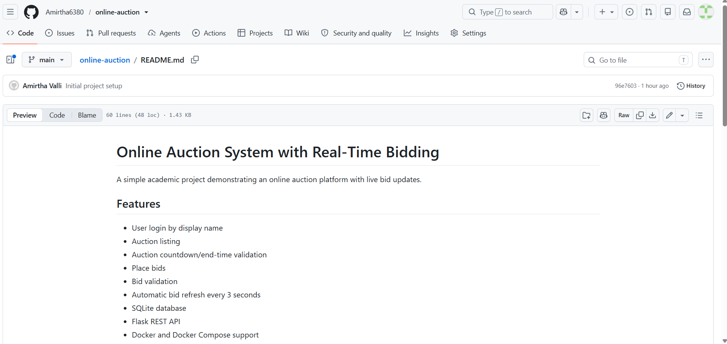
Figure 10: Project README

6.2 Installation Instructions
The repository should provide clear steps for installing and running the application.
A general procedure is:
- Clone the repository.
- Open the project directory.
- Install the required dependencies.
- Configure required environment variables.
- Start the application.
- Open the application using the specified localhost address.
If Docker is used:
- Install Docker.
- Clone the repository.
- Open the project directory.
- Build the Docker image or start the Docker Compose configuration.
- Run the application container.
- Access the application through the configured localhost port.

6.3 Dependencies
The project may depend on programming frameworks, libraries, database software, or runtime environments.
All important dependencies should be listed in the repository so that another developer can reproduce the development environment.
Examples include:
- Programming language runtime.
- Web framework.
- Database.
- Frontend libraries.
- Backend libraries.
- Docker.
- Other project-specific packages.
The exact dependencies should be documented in the project's dependency/configuration file.

6.4 Usage Guide
The README should explain how a user interacts with the application.
A typical usage process is:
Open Application
↓
Login
↓
View Auction
↓
Select Auction Item
↓
Enter Bid
↓
Bid Validation
↓
Bid Accepted / Rejected
↓
Auction Ends
This process helps new users understand the application without requiring detailed knowledge of the source code.
6.5 Documentation Improvements
The following improvements are recommended:
- Add complete installation instructions.
- Clearly mention software prerequisites.
- Explain all required dependencies.
- Add screenshots of important application pages.
- Explain how to run the project using Docker.
- Add testing instructions.
- Explain important configuration variables.
- Add troubleshooting information.
- Keep the README updated when new features are added.

- CODE REVIEW FINDINGS AND RECOMMENDATIONS

7.1 Overall Findings
The Online Auction System demonstrates the basic functionality required for an online auction application. The application provides user access, auction information, bidding functionality, and auction completion handling.
The repository provides a foundation for maintaining and further developing the application.
The major positive aspects identified during the review are:
- Clear project objective.
- Working user interface.
- Login functionality.
- Auction functionality.
- Bid validation.
- Auction-ending condition.
- Git-based source-code management.
- Docker-based execution, where applicable.

7.2 Code Quality Recommendations
The following improvements are recommended:
Improve Modularity
Separate application functionality into smaller modules. Login, auction management, bidding, and user management should have clearly separated responsibilities.
Improve Error Handling
The application should handle invalid user input and unexpected errors gracefully.
Improve Input Validation
All user-provided values should be validated before processing.
Avoid Duplicate Code
Repeated logic should be converted into reusable functions or components.
Improve Comments
Important and complex logic should contain meaningful comments.
7.3 Version Control Recommendations
The following Git practices are recommended:
- Use meaningful commit messages.
- Create feature branches for major changes.
- Merge completed features into the main branch.
- Avoid committing unnecessary files.
- Use .gitignore.
- Create release tags for stable versions.
- Maintain a clean commit history.

7.4 Testing Recommendations
Testing can be improved by introducing automated testing.
Future tests can include:
- Unit testing.
- Integration testing.
- API testing.
- User-interface testing.
- Security testing.
- Performance testing.
- Concurrent bidding testing.
Concurrent bidding is particularly important for an auction system because multiple users may attempt to place bids at the same time.

7.5 Documentation Recommendations
The README should be continuously updated as the project develops.
It should contain:
- Project overview.
- Features.
- System requirements.
- Installation instructions.
- Docker instructions.
- Configuration details.
- Usage guide.
- Testing procedure.
- Screenshots.
- Known limitations.
- Future enhancements.

7.6 Future Enhancements
The following features can be implemented in future versions:
- User registration.
- Secure password encryption.
- Multiple auction items.
- Real-time bid updates.
- Bid history.
- Automatic auction winner selection.
- Email notifications.
- Admin dashboard.
- Auction scheduling.
- Payment integration.
- Search and filtering.
- User profile management.
- Improved authentication and authorization.
- Database-based persistent bid storage.
- Real-time communication using WebSocket technology.

8. OVERALL CODE REVIEW SUMMARY
Evaluation Area | Observation | Improvement
Problem Definition | Clear online auction objective | Add more detailed requirements
Repository Structure | Files are organized according to project functionality | Improve separation of modules
Code Quality | Core functionality is implemented | Improve modularity and error handling
Naming | Functional names are used | Maintain consistent conventions
Documentation | README provides project information | Add complete setup and usage instructions
Version Control | Git/GitHub used for project management | Improve commit messages and branching
Testing | Functional test cases performed | Add automated testing
Deployment | Docker can provide consistent execution | Improve deployment documentation
Maintainability | Project can be extended | Improve code documentation and modularity

9. CONCLUSION
The Code Review and Repository Evaluation of the Online Auction System with Real-Time Bidding demonstrates that the project provides the basic functionality required for an online auction platform.
The review covered the problem definition, repository organization, source-code quality, version-control practices, testing, documentation, and maintainability.
The project has important functional components such as user login, auction display, bidding, bid validation, and auction-ending handling. Git and GitHub provide version-control capabilities, while Docker provides a consistent environment for application execution where applicable.
The review also identified areas for improvement, including better modularity, stronger input validation, improved error handling, automated testing, clearer documentation, and a more structured branching strategy.
With these improvements, the Online Auction System can become more scalable, secure, maintainable, and suitable for real-world deployment.

10. REFERENCES
- Git Documentation – Version Control and Repository Management.
- GitHub Documentation – Repository and Collaboration Features.
- Docker Documentation – Containerization and Application Deployment.
- Documentation of the programming language/framework used in the project.
- Project GitHub Repository: ____________ https://github.com/Amirtha6380/online-auction.git
- Project source code and implementation files.

